Saint Louis Public Schools Early Childhood Education Department
Pre-Kindergarten
Week (date) | Teacher Name | Site Name | # of Students
August 30-September 3 | Sanders | Adams | 14
Pre-K families will receive ongoing communication throughout the Virtual Learning time period.
Objective | Students will learn about navigating the teacher website and completing assignments posted through the site. Students and caregivers will learn how-to navigate MS Teams app. Students will learn virtual learning expectations & routines.

Webpage Assignments   | Visit the Adams Webpage. View the Welcome Back Video school video (will be updated by Wednesday). School Website
 | Visit Dr. Sanders’s webpage
Email Message (copy/paste when you e-mail Ms. Matthews): to get log-in information for access to Starfall.com.

“Hello! I am requesting my student log-in information for Starfall.com. My students’ name is: ________.

Thank you, _____”
(Please fill in the blanks with your students’ name and your name.)

 | Remind is an app that is used for easy communication between teacher parents and each other. Join Remind by clicking on this link Join Remind
Read the mini-book from the Ziploc bag: “At School”.
- Circle all the letters/words you know. Copy/write them on a piece of lined paper. Email/text a picture of the paper to Dr. Sanders
- Ask the students: What can you DO at school? What do you think we can do with Virtual School? What fun things do you want to do with Dr. Sanders & our friends this year?
Draw a picture of what our Virtual Classroom looks like! What fun things do you want to have in our room? What fun things do you like to do? Email/text a picture of the drawing to Dr. Sanders
 | Sign on to Teams (probably Thursday or Friday) navigate through the site to see what it has to offer)

Webpage Read-Alouds   | The Night Before Preschool by Natasha Wing read by Dr. Sanders
 | All by Myself by Mercer Mayer read by Dr. Sanders

Webpage Lessons  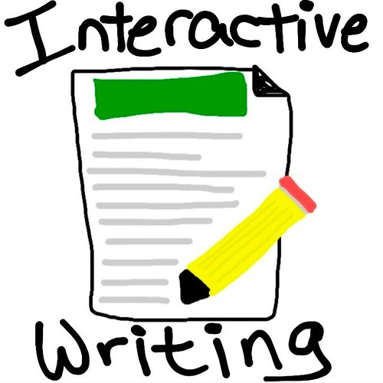 | Complete the google form and these assignments from each of the books  The Night Before Preschool by Natasha Wing read by Dr. Sanders  - Activity: Draw a picture about the Night Before Preschool. What did you do to get ready for school? What do you want to learn? (Parents—write down what your child tells you at the bottom/side of the picture they drew. Make sure they write their name somewhere on the paper!). Email/text a picture of the drawing to Dr. Sanders!  All by Myself by Mercer Mayer read by Dr. Sanders  - Complete google form  - Ask students/discuss: What is something you want to learn how to do? How can we work together to learn this new thing? Draw a picture of All the Things Want to Learn How to Do. What do you want to learn how to do? What do you want to learn about? (Parents—write down what your child tells you at the bottom/side of the picture they drew. Make sure they “write their name” somewhere on the paper!)
 | Watch the lesson about the Foot Counters by Dr. Sanders. Look at your “foot” counters. What colors do you have? How many do you have in all? How many of each color?

Communication with Families
  Monday/Wednesday Check In |   Tuesday/Thursday Check In

